Birla Institute of Technology & Science, Pilani
Work Integrated Learning Programmes Division
Second Semester 2023-2024
Mid-Semester Test (EC-2 Regular)

Course No. : SS ZC416
Course Title : Mathematicals Foundation for Data Science
Nature of Exam : Closed Book
Weightage : 30%
No. of Pages = 2

No. of Questions = 10
Duration : 2 Hours
Date of Exam : 17/03/2024 (FN)
Note to Students:
- Please follow all the instructions for candidates given on the cover page of the answer book.
- All parts of a question should be answered consecutively. Each answer should start from a fresh page.
- Assumptions made, if any, should be stated clearly at the beginning of your answer.

- Consider the three planes in three-dimensional space. Find the condition on ‘a’ such that the three planes have a (a) common point of intersection (b) common plane of intersection. [3 marks]

- Find the eigenvalues and eigenvectors of 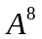, where 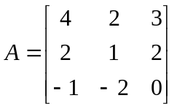. [3 marks]

- Find the eigenvalue decomposition (if possible) for 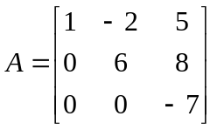. [3 marks]

- Let 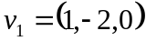, 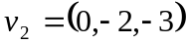 and 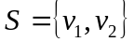. Find a vector u such that S ∪ {u} is linearly independent. Find a vector v such that S ∪ {v} is linearly dependent. [2 marks]

- Find a basis for the null space of the matrix 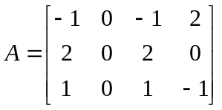. [3 marks]

- Let 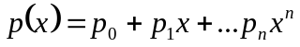 and 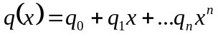 be polynomials of degree at most ‘n.’ Define an inner product on the associated vector space ‘V’ as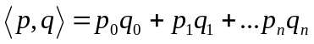. Show that V is an inner product space, compute 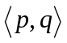,  and the distance between  and where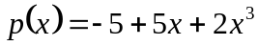, and 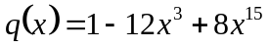 [4 marks]

- Find the linearization of 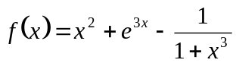 at 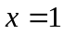. [2 marks]

- Discuss the extremum of the function 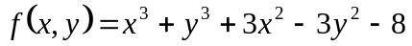. [3 marks]

- Using the backpropagation algorithm, compute the derivative of the function [4 marks]

- Compute all possible derivatives of order 2 for the function 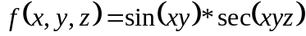. [3 marks]

***************

